PIZZA SALES SQL QUERIES

A. KPI’s

1. SELECT SUM(TOTAL_PRICE) AS TOTAL_REVENUE FROM PIZZA_SALES

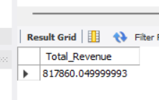

1. Select (sum(total_price) / count(distinct order_id)) as Avg_Order_value from pizza_sales

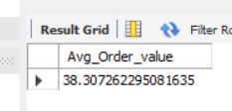

1. select sum(quantity) as Total_Sold_Qty from pizza_sales

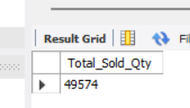

1. select count(distinct order_id) as Total_Orders from pizza_sales

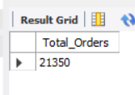

1. select cast(cast(sum(quantity) as decimal (10,2)) / cast(count(distinct order_id) as decimal (10,2)) as decimal (10,2)) as Avg_Pizza_PerOrder from pizza_sales

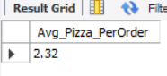

DRAWING CHARTS

1. SELECT DAYNAME(DATE(order_date)) AS order_day, COUNT(order_id) AS Total_Orders

FROM pizza_sales

GROUP BY DAYNAME(DATE(order_date));

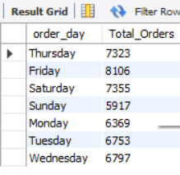

1. SELECT monthname(date(order_date)) as Month_Name, count(distinct order_id) as orders

from pizza_sales

group by monthname(date(order_date))

ORDER BY orders DESC;

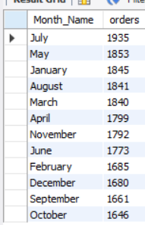

1. select pizza_category, sum(total_price)*100/(select sum(total_price) from pizza_sales) as Total_Sales_Cat from pizza_sales group by pizza_category;

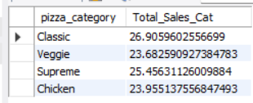

1. select pizza_size, cast(sum(total_price) as decimal (10,2)) as Total_Sales,

cast(sum(total_price) *100/ (select sum(total_price) from pizza_sales) as decimal (10,2)) as PCT

from pizza_sales

group by pizza_size

order by Total_Sales desc;

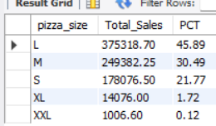

1. select pizza_name, sum(total_price) as total_revenue

from pizza_sales

group by pizza_name

order by total_revenue desc limit 5;

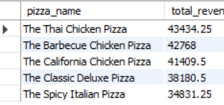

1. select pizza_name, sum(total_price) as total_revenue

from pizza_sales

group by pizza_name

order by total_revenue limit 5;

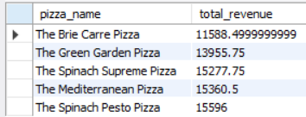

1. select pizza_name, sum(quantity) as total_quantity

from pizza_sales

group by pizza_name

order by total_quantity desc limit 5;

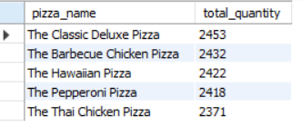

1. select pizza_name, sum(quantity) as total_quantity

from pizza_sales

group by pizza_name

order by total_quantity limit 5;

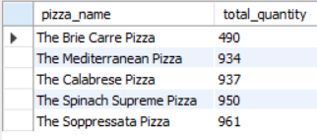

1. select pizza_name, count(distinct order_id) as total_orders

from pizza_sales

group by pizza_name

order by total_orders desc limit 5;

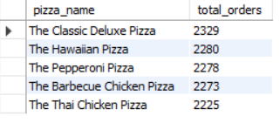

1. select pizza_name, count(distinct order_id) as total_orders

from pizza_sales

group by pizza_name

order by total_orders limit 5;

